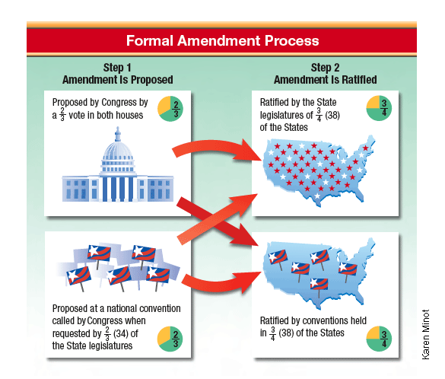
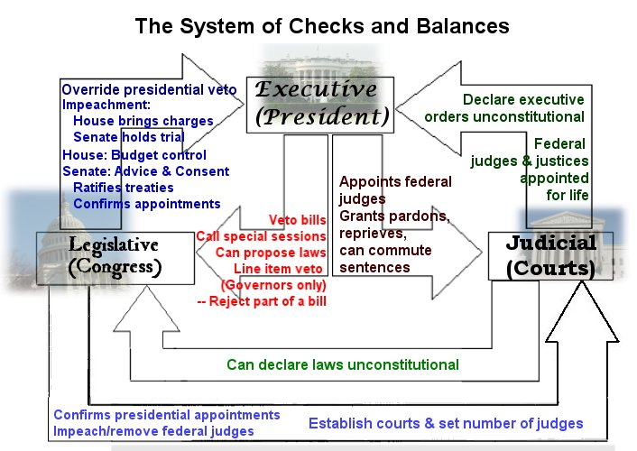

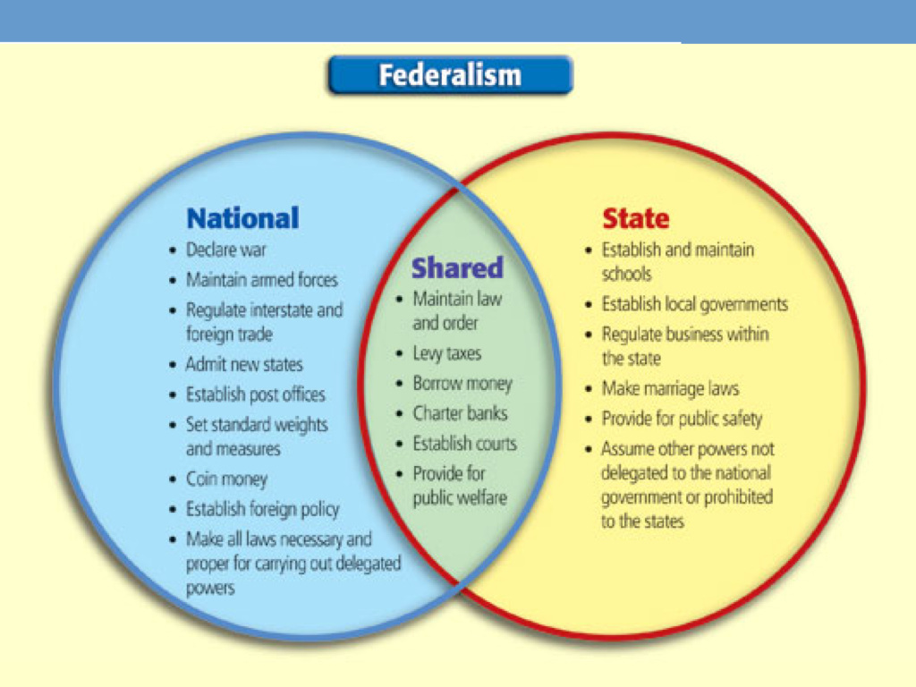
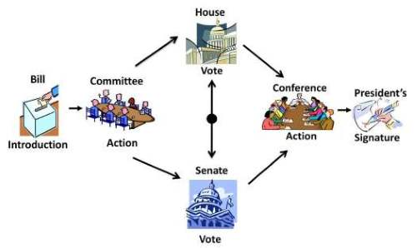
President can choose to sign the bill or veto the bill
Simple majority in both houses to pass the bill through

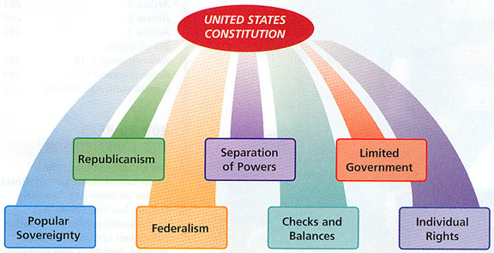

Position | Term | Term Limit | Minimum Age | Residency | Citizenship
Representative | 2 years | No limit | 25 | State in which elected | 7 years
Senator | 6 years | No limit | 30 | State in which elected | 9 years
President | 4 years | 2 terms | 35 | 14 years in the U.S. | Natural Born

